HT12D Decoder IC
CP040
Image:
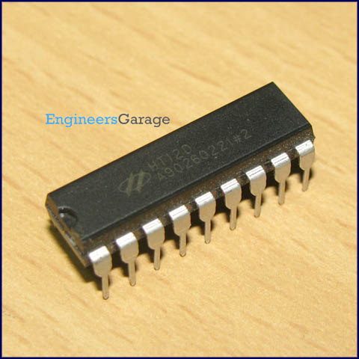
DataSheet:
HT12D.PDF
HT12D is a decoder integrated circuit that belongs to 2¹² series of decoders. This series of decoders are mainly used for remote control system applications, like burglar alarm, car door controller, security system etc. It is mainly provided to interface RF and infrared circuits. They are paired with 2¹² series of encoders. The chosen pair of encoder/decoder should have same number of addresses and data format.

In simple terms, HT12D converts the serial input into parallel outputs. It decodes the serial addresses and data received by, say, an RF receiver, into parallel data and sends them to output data pins. The serial input data is compared with the local addresses three times continuously. The input data code is decoded when no error or unmatched codes are found. A valid transmission in indicated by a high signal at VT pin.

HT12D is capable of decoding 12 bits, of which 8 are address bits and 4 are data bits. The data on 4 bit latch type output pins remain unchanged until new is received.

Pin Diagram:
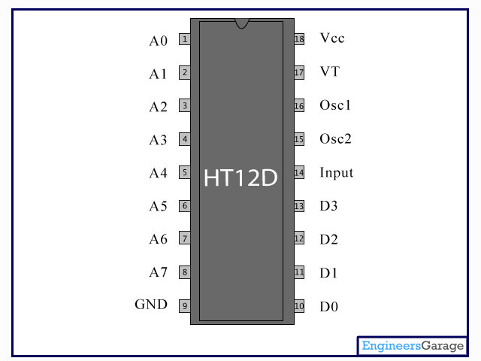
Pin Description:

Pin No | Function | Name
1 | 8 bit Address pins for input | A0
2 | 8 bit Address pins for input | A1
3 | 8 bit Address pins for input | A2
4 | 8 bit Address pins for input | A3
5 | 8 bit Address pins for input | A4
6 | 8 bit Address pins for input | A5
7 | 8 bit Address pins for input | A6
8 | 8 bit Address pins for input | A7
9 | Ground (0V) | Ground
10 | 4 bit Data/Address pins for output | D0
11 | 4 bit Data/Address pins for output | D1
12 | 4 bit Data/Address pins for output | D2
13 | 4 bit Data/Address pins for output | D3
14 | Serial data input | Input
15 | Oscillator output | Osc2
16 | Oscillator input | Osc1
17 | Valid transmission; active high | VT
18 | Supply voltage; 5V (2.4V-12V) | Vcc

